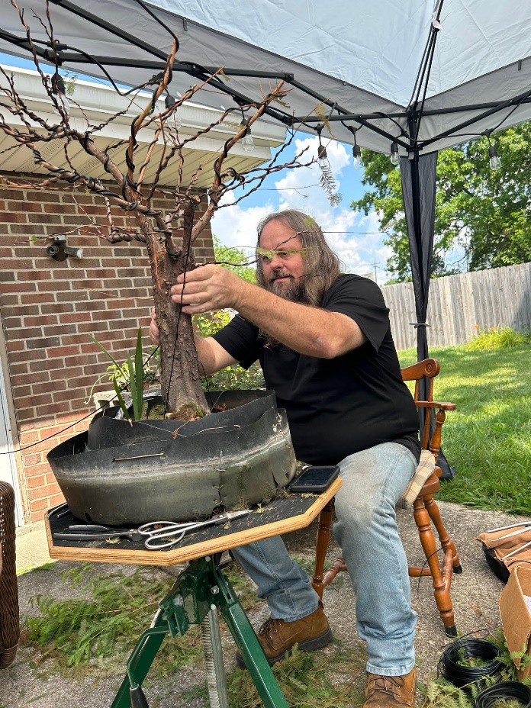 | The Bonsai Society of Miami will be hosting Adam Lavigne at our January 9th, 2024 meeting to do a demonstration.  Meeting will be held at Pinecrest Gardens  11100 Red Road  Pinecrest FL  In the Hibiscus Room  7:15 PM  Observers – Donations Accepted

Adam Lavigne has dedicated approximately two decades to mastering the art of bonsai, learning from seasoned practitioners in Florida, as well as renowned masters across the United States. He is celebrated for his skills in carving, horticulture, wiring, and his signature technique, the "Adamaskwhy trunk chop."
Adam's blog, Adamaskwhy.com, is a comprehensive resource with close to 600 articles covering a wide range of bonsai-related topics, including pottery, stand making, carving, repotting, and soil compositions. The blog also features numerous posts that document the transformation of trees from their raw form to exhibition-ready states.
Adam is recognized for challenging traditional bonsai ideas and practices, advocating for continuous learning and the ongoing evolution of both the science and the artistic perception of bonsai. He encourages a dynamic and modern understanding of the art, aligning with the contemporary state of bonsai.
Adam Lavigne
Adamaskwhy.com

Adam will style and do some carving on the tree.
The tree is a Bald Cypress and will be raffled off after his program.
Tickets are $10.00 each or 6 for $50.00
Refreshments will be served

